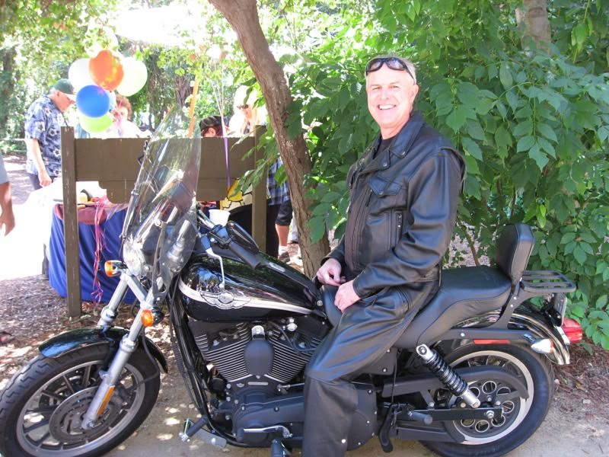
Dan Hodgson has been a spiritual father to this house for over 16 years. He has ministered to the family here and has served as a board member in praying and releasing direction here at Vineyard Church Salinas.

He has served as Area Pastor for the ten Central Coast Vineyards from Santa Barbara to Salinas.

With his heart of love for the Santa Barbara area he planted and pastored the Goleta Vineyard for 30 years with his wife Barbara. They have been married 44 years, and have three married children—a son and two daughters—and six grandchildren.

Dan has been released as Ambassador at Large to pastor Pastors, churches, leaders, and ministries—including ministries such as:
- Santa Barbara House of Prayer
- Tribalwinds YWAM Base to reach Hopi in Northern AZ
- First Nations in the U.S. and beyond
- Eglise Vivante Churches in Burundi and Rwanda
- Living Word Churches in Kenya

He writes Leadership Training Materials to help minister to all the above.

He has a passion for the whole revelation of the Kingdom to be proclaimed, experienced, and imparted.

His contact information is:

Dan Hodgson
codenamed@aol.com

